Secondary Species - Sheep

Maestrale et al. 2013. Pathology in Practice. JAVMA 242(2):179-181

SUMMARY:

History: During 3 consecutive breeding seasons, a number of lambs had died shortly after birth in a flock of Sarda sheep in Sardinia. Affected lambs had hairless areas of skin on the limbs and pinnae; the hooves were absent in 1 lamb. The flock included approximately 300 ewes and 4 rams, and records indicated that 10 lambs were affected with this congenital skin disorder within the preceding year. Flock feeding relied on the exploitation of natural pastures; the diet was supplemented with concentrate and hay during the milking period. The owner reported that no new introduction of sheep had occurred before the onset of the first clinical case. A dead female lamb was transported to the diagnostic laboratories of the Istituto Zooprofilattico Sperimentale della Sardegna for postmortem examination and subsequent histologic and immunohistochemical (IHC) investigations.

Morphologic Diagnosis: congenital, focal aplasia of the epidermis and adnexal structures, associated with superficial necrosis and extensive dermal inflammation.

Case Summary: Epitheliogenesis imperfecta (EI) in a lamb.

QUESTIONS
1. Macroscopically, there were symmetric, reddish, translucent, and well-demarcated alopecic skin areas on the pinnae and the more distal portions of the forelimbs (Figure 1). No additional lesions involving other organs were identified during necropsy. T or F

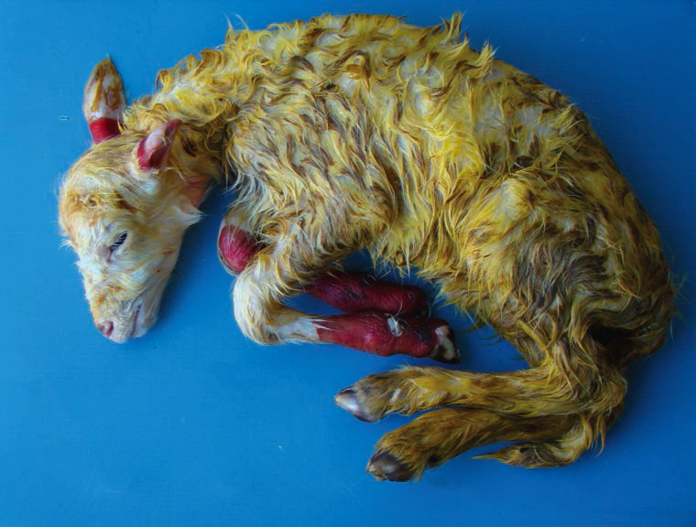

Figure 1—Photograph of a Sarda breed lamb with bilateral hairless, reddish skin lesions on the pinnae and lower regions of the forelimbs. The lamb had been found dead at the farm 2 hours after birth. In the farm’s flock, a number of lambs had died shortly after birth during 3 consecutive breeding seasons.

2. Microscopically, the damaged skin areas lacked epidermis, including basement membrane, as well as adnexal structures (hair follicles, sebaceous glands, and sweat glands). At the junction between unaffected skin and affected tissue, the epidermis ended abruptly, with its margins remaining strongly adherent to (Figure 2) or, rarely, detached from the underlying dermis. T or F

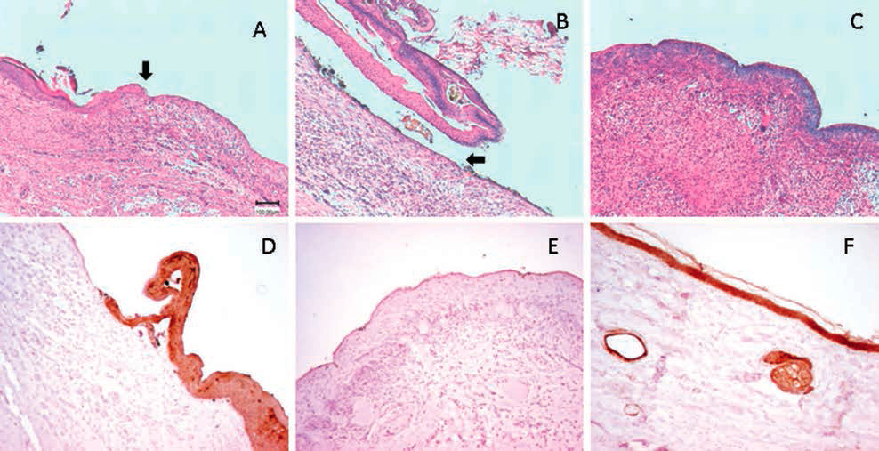

Figure 2—Photomicrographs of sections of skin of the Sarda breed lamb in Figure 1 that underwent H&E staining (A, B, and C) for histologic examination or immunohistochemical staining (D, E, and F) to detect cytokeratin (by use of a routine biotin-streptavidin method, which included monoclonal primary antibody against antigenic determinants of most of the subfamily A and B cytokeratins, use of 3,3’-diaminobenzidine tetrahydrochloride as the chromogen, and Meyer hematoxylin counterstaining). A—Section of an auricle at the junction between unaffected and affected skin. Unaffected skin ends abruptly (arrow), with the epidermis remaining strongly adherent to the underlying dermal component. B— Another view of the section of skin from the auricle in panel A at the junction between unaffected and affected areas. The terminal portion of the epidermis appears to be detached from the underlying dermal component (arrow). C—Section of skin obtained from an affected forelimb. All epidermal layers are missing, and an abundant inflammatory infiltrate composed of neutrophils and lymphocytes is present throughout the dermis. D—Section of skin at the junction of unaffected and affected skin of an auricle. The cytokeratin immunolabeling is restricted to normal skin. E—Section of skin obtained from an affected forelimb. No cytokeratin immunolabeling is evident demonstrating the absence of keratinocytes from affected skin areas. F—Section of skin obtained from an unaffected hind limb. Keratinocytes in apparently normal skin are strongly and uniformly labeled for cytokeratin. Bar = 100 m (applies to all panels).

3. EI is a rare congenital pathological condition, which has been described in human as aplasia cutis and which of the following species has been described:
a. Cattle
b. Swine
c. Sheep
d. Horses
e. All of the above
4. EI–associated lesions are characterized by the absence of squamous epithelia in variably sized areas of the skin and mucous membranes. Also, it has been reported in mice homozygous for a disrupted p63 gene (a homologue of the tumor suppressor p53) indicated that congenital defects of squamosus epithelia development in the skin maybe associated with absence of the epithelial appendages. (Yang, A. et; al. Nature 1999; 398, 714-718). T or F
5. EI is suggested to be a sex-related condition in which of the following species:
a. Swine
b. Lambs
c. Horses
d. Cattle
e. All of the above
6. Epidermolysis bullosa includes a group of hereditary mechanobullous diseases characterized by cutaneous blisters in response to trauma often misdiagnosed as EI. T or F
7. Epidermolysis bullosa has been associated in horses and sheep with partial deletion of LAMA3 and LAMC2 genes that encode for 2 laminin subunits. Laminin is one of the most important components of the basement membrane of the epidermis. T or F

ANSWERS
1. T
2. T
3. e
4. T
5. a
6. T
7. T

Kelly et al. 2012. Pathology in Practice. JAVMA 241(11):1449-1452

Domain 1: Management of Spontaneous and Experimentally Induced Diseases and Conditions; Task T3 Diagnose disease or condition as appropriate; Knowledge K3. parasitology with emphasis on parasitic diseases that can become established in a colony and zoonotic parasitic diseases

SUMMARY: This article presents a sheep whose carcass was submitted for examination by a meat inspector. The gross pathology findings include thick-walled cysts in the liver and all lung lobes. The morphologic diagnosis from histopathology was widespread multifocal pulmonary and hepatic cysts with intralesional cestodes consistent with Echinococcus granulomas.
Echinococcosis is a zoonotic, reportable disease that still affects many people throughout the world with the highest prevalence of human infections occurring in sheep-raising areas. The definitive hosts are dogs and other carnivores. The intermediate hosts are generally herbivores such as sheep, cattle, and deer. Humans are aberrant or dead-end hosts. Cestodes in dog or sheep are of the largest concern regarding transmission to humans especially people with family pet sheep dogs and people in contact with flocks.

This parasite is not only a health concern but it is also an economic concern with decreased production and when carcasses or organs are condemned. Preventive measures to reduce disease includes educated the public, deworming sheep dogs, prevent dogs from gaining access to affected organs, reduce the stray dog population, and good human hygiene since humans are affected by the fecal-oral route. Additionally, wildlife reservoirs such as coyotes may be contributing to transmission. Identification of animals affected with this parasite and knowledge of prevention may help reduce cases and transmission from animal to animal or animal to human.

QUESTIONS
1. What is the correct order and family of sheep?
a. Order: Artiodactyla, Family: Bovis
b. Order: Rumenantia; Family: Ovis
c. Order: Artiodactyla, Family: Bovidae
d. Order: Rumenantia; Family: Ovidae
2. Which of the following is NOT a zoonotic disease of concern with sheep?
a. Orf (contagious ecthyema)
b. Listeriosis
c. Chlamydiosis
d. Toxoplasmosis
e. None of the above
3. Induced research models of sheep include:
a. Arteriosclerosis
b. Metabolic toxocosis
c. Copper poisoning
d. All of the above
e. None of the above

ANSWERS
1. c.
2. e.
3. d.

Wenzel et al. 2012. Pathology in Practice. JAVMA 241(7):885-887

Task 1: Prevent, diagnose, control, and treat disease

SUMMARY: This is a case report of an 11-year-old castrated male Jacob breed sheep that presented for a 2.5-month history of recurrent nasal discharge and increased respiratory effort. Bloodwork was unremarkable, as were vital signs. Right lung sounds were increased, inspiration was stertorous, and there was clear to white ropey right sided nasal discharge with occasional epistaxis. Chest radiographs were unremarkable, but there was increased radioopacity of the right nasal cavity. Nasal cultures revealed Pseudomonas, Staphylococcus, and Acinebacter, so the animal was placed on enrofloxacin. Antimicrobial therapy was initially positive, but about 1 month later a mass was seen extruding from the right nasal passage. The mass was manually removed and was observed to be 10x2 cm nd 0.5 cm wide. It was black to red and firm at one side, and opaque and gelatinous at the other. Following removal respiratory effort improved temporarily, after which clinical signs returned and another mass was observed in the nasal passage. Given the aggressive nature of the mass, the animal was euthanized. At necropsy a mass was observed to occupy the frontal sinus. Histopathology revealed loose, fibroblastic stroma with extensive myxedema and numerous small caliber blood vessels, with evidence of moderate to severe lymphoplasmacytic and neutrophilic inflammation. Diagnosis was chronic, focally extensive, unilateral myxomatous polyp, with frontal bone inflammation and unilateral marked lymphoplasmacytic and neutrophilic ulcerative rhinitis and sinusitis.

QUESTIONS:
1. T/F: Nasal and nasopharyngeal polyps are typically benign inflammatory growths.
2. In which of the following species have nasal and nasopharyngeal polyps not been reported?
a. Sheep
b. Horses
c. Cats
d. Chickens
3. Where do nasopharyngeal polyps originate?
a. Ethmoturbinates
b. Middle ear canal
c. Soft palate
4. What process causes the formation of spherocytes?

ANSWERS:
1. T
2. d
3. b

Hampton et al. 2012. Pathology in Practice. JAVMA 240(11):1293-1295

Domain 1: Management of Spontaneous and Experimentally Induced Diseases and Conditions
Secondary Species: Sheep (Ovis aries)

SUMMARY: A 3-week-old female Suffolk lamb housed at the University of Michigan Sheep Research Facility presented for a large, well-demarcated, ulcerated, perianal mass with serous discharge. Within a week, the lamb developed additional raised, crusty lesions on the tail and perivulvar region and 7 additional lambs developed similar lesions. All experimental groups, including controls, were affected. Males and females were equally affected. Two weeks earlier, all the lambs underwent routine processing procedures, including tail-docking by electrocautery.
Histological examination of a punch biopsy specimen of the mass was non-diagnostic. FNA of the mass revealed a mixed population of bacteria and neutrophils. Aerobic culture grew E. coli and Staph. aureus. The animal was treated with Durapen, but clinical signs did not improve. Histopathology of an excisional biopsy was consistent with a morphologic diagnosis of severe, proliferative dermatitis with epidermal hyperkeratosis and intracytoplasmic inclusion bodies (poxviral inclusions), consistent with contagious ecthyma (orf), a parapoxvirus infection.

Orf is a common viral skin infection in sheep caused by ovine parapoxvirus. It is also known as contagious ecthyma, sore mouth, scabby mouth, contagious pustular dermatitis, and cutaneous pustular dermatitis. Mortality is low but morbidity is high. Complete resolution occurs about 6-8 weeks after initial appearance of lesions. It can be complicated by secondary bacterial infections. The histopathology seen here along with characteristic facial lesions are pathognomonic. It must be differentiated from sheep pox (capripoxvirus), a foreign animal disease, in imported animals. It is potentially zoonotic, and causes painful skin lesions in naïve human hosts. The crusts are highly infectious and remain stable in the environment for years. In this case, viral entry was likely through the tail wound created after docking and exposure to the environment. This is the second report of epizootic orf after routine tail docking.

QUESTIONS:
1. Antibiotics!
a. What are the two forms of penicillin in Durapen and why are they combined into one formulation?
b. Are penicillins primarily bactericidal or bacteriostatic?
c. Do penicillins primarily exhibit time-dependent or concentration-dependent killing?
2. What kind of virus is parapox virus?

ANSWERS:
1. Each mL contains 150,000 IU penicillin G procaine and 150,000 IU penicillin G benzathine. The procaine form is absorbed and eliminated quickly and provides local analgesia. The benzathine form is absorbed and eliminated slowly. Penicillins are bactericidal and time-dependent. That is why adding a component with a long half-life (benzathine) helps maximize efficacy.
2. Enveloped ds DNA, Baltimore group I

